CHAT APPLICATION
@CREATIVITY THINK (9483175986/7019689991)

ABSTRACT:
The Chat Application is a real-time communication platform built to support direct messaging, group chats, file sharing, emojis, live online status, and dashboard conversation logs. Designed for teams, workplaces, friends, and support groups, the system ensures fast, reliable, and interactive communication. Users can add friends or groups, send messages instantly, share files, and view chat history with notifications. Administrators can manage chat rooms, monitor activities, enforce bans, and review audit/security logs. The system uses Django and Django REST Framework for backend management and Socket.io with React and Redux for real-time communication on the frontend..

INTRODUCTION OF THE PROJECT:
Real-time communication has become essential for businesses, educational institutions, and informal communities. Traditional text-based messaging apps lack centralized moderation, file sharing, or real-time presence detection. This Chat Application addresses these gaps by offering an integrated, scalable system that supports instant messaging, multimedia sharing, group communication, and activity monitoring. With Socket.io handling real-time message delivery and Django managing backend logic, the application ensures stability, speed, and responsive user experience across all devices..

PROJECT OBJECTIVES:

• Enable real-time messaging for groups and direct chats.
• Provide file sharing with secure uploads.
• Offer emojis and reactions for expressive communication.
• Display online/offline/typing statuses in real time.
• Allow users to maintain chat history and receive notifications.
• Enable administrators to monitor and moderate chat rooms.
• Provide a dashboard for activity logs, audit trails, and abuse handling.
• Ensure secure, scalable, and low-latency communication.

PROBLEM OF THE STATEMENT:
Many online chat platforms lack proper moderation tools, secure file sharing, or integrated group management. Businesses often struggle with slow, outdated communication systems that fail to support real-time updates or structured user control. Additionally, data security and audit trail tracking are common challenges. This Chat Application resolves these issues by providing a modern, real-time, secure, and admin-controlled messaging platform that includes comprehensive monitoring, file sharing, activity logs, and communication channels suited for both formal and informal environments..

MOTIVATION OF THE PROJECT:
• To create a dedicated real-time communication tool for teams and groups.
• To improve collaboration with instant messaging and presence indicators.
• To offer a secure alternative to third-party messaging apps.
• To provide structured moderation controls for administrators.
• To support multimedia sharing for improved interaction.
• To ensure a scalable architecture suitable for growing organizations.

BLOCK DAIGRAM OF PROJECT:

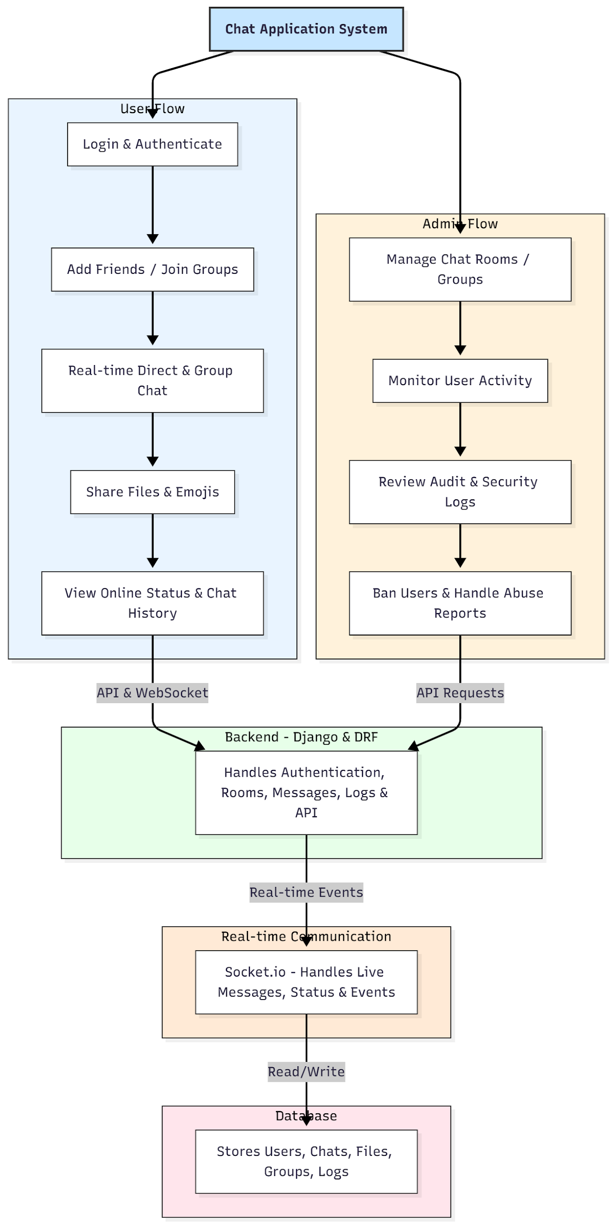

WORKING OF THE PROJECT:
The system starts with user authentication, after which users can search and add friends, join groups, or create new chat rooms. Messages are transmitted instantly using Socket.io, ensuring minimal latency and real-time synchronization. Typing indicators, online status, and read receipts are updated in real time. File uploads are processed through Django APIs and stored securely. Chat history is saved in the database and displayed through Redux-managed states. Administrators use a dedicated dashboard to oversee chat rooms, monitor user activity, review audit logs, handle abuse reports, and perform user bans. The combination of REST APIs and WebSockets provides a robust hybrid architecture for efficient communication..

SOFTWARE REQUIREMENT:
- Backend:
  - Python 3.x
  - Django
  - Django REST Framework
  - SQLite/PostgreSQL
- Frontend:
  - Node.js and npm
  - React.js
  - Axios
- Development Tools:
  - Visual Studio Code
  - Postman (for testing APIs)
  - Git/GitHub (for version control)
- Server/Deployment (Optional):
  - Gunicorn, Nginx, or Heroku/AWS for hosting

ADVANTAGES OF THE PROJECT:

• Real-time communication with minimal delays.
• Group and direct chat support with file sharing.
• Online, typing, and active status indicators.
• Moderation tools for safe and controlled communication.
• Emoji support and multimedia-rich interactions.
• Chat logs, audit trails, and user monitoring.
• Scalable architecture suitable for large user bases.
• Secure authentication and protected file sharing.

APPLICATIONS OF THE PROJECT:
• Team collaboration platforms
• Corporate workplace communication
• Customer support and helpdesk chat
• Friends and community groups
• Classroom or educational discussion rooms
• Study groups and project teams

REFERENCES:

- Django REST Framework Documentation — Django Software Foundation. Django Documentation. Available: https://docs.djangoproject.com/
- Django REST Framework. DRF Documentation. Available: https://www.django-rest-framework.org/
- React. React Official Documentation. Available: https://reactjs.org/docs/getting-started.html
- Redux. Redux Documentation. Available: https://redux.js.org/introduction/getting-started
- PostgreSQL Global Development Group. PostgreSQL Documentation. Available: https://www.postgresql.org/docs/
- MySQL. MySQL Reference Manual. Available: https://dev.mysql.com/doc/
- Git. Git Documentation. Available: https://git-scm.com/doc
- Node.js. Node.js Documentation. Available: https://nodejs.org/en/docs/
- Axios. Axios Documentation. Available: https://axios-http.com/docs/intro
- Socket.io Documentation – https://socket.io/docs/

